PROGRAM FOR TEMPERATURE DETECTION:

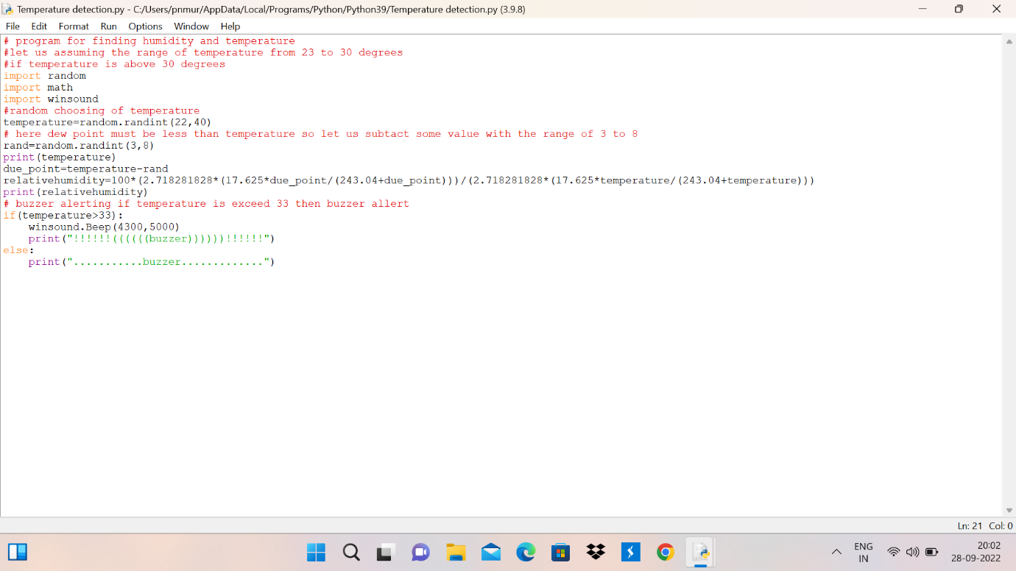

OUTPUT:

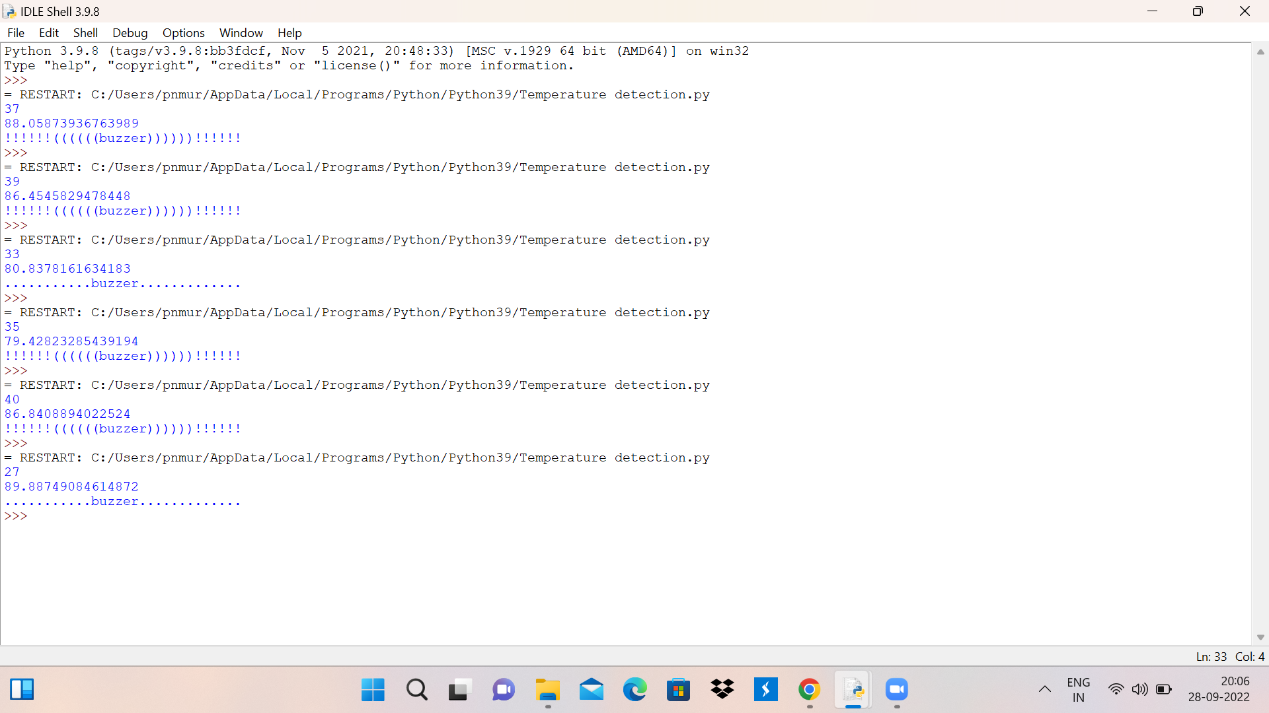

VIDEO LINK:

<https://drive.google.com/file/d/1leE8u95HIKimjSNzF3dor3iUGjp-zVD1/view?usp=sharing>

POLA NAGAMURALI PRASAD

111519106115